Hello Everyone,

I wanted to reach out with information respecting vigilance and crime prevention for businesses. Unfortunately, several businesses on Locke Street were vandalized last night which is a pattern we have been seeing, after what we had happen here on Concession Street earlier this week. It is absolutely terrible that there are some people who would commit these acts during these times when everyone is trying to get by.

This information has been shared with the Emergency Operations Centre and our Acting City Manager, Jason Thorne, is working with the Hamilton Police on these crucial issues.

Ahead of further direction and messaging I wanted to provide some information that can be adopted and shared with your memberships. These are some crime prevention tips and checklists from Hamilton Police or that I have come across that I hope are useful tools for businesses.

Business Security

<https://hamiltonpolice.on.ca/prevention/business-home-security>

Crime Prevention Through Environmental Design

<https://hamiltonpolice.on.ca/prevention/business-home-security/cpted>

I would also like to share a business checklist from the City of Ottawa, something that offers simple tips and tricks to hopefully help businesses:

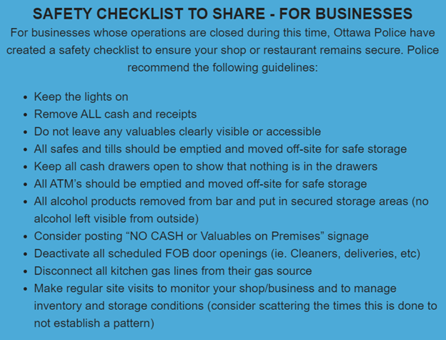

I also want to advise that if businesses within your BIA are vandalized, there was an amendment a few years ago to the BUSINESS IMPROVEMENT AREA COMMERCIAL PROPERTY IMPROVEMENT GRANT PROGRAM. This amendment was put in place to assist commercial property owners / authorized tenants to repair property damage due to fire, vandalism or a natural disaster such as a flood, earthquake or hurricane will help mitigate some of the capital improvements costs involved during the recovery phase. <https://investinhamilton.ca/tools-data/financial-incentives/municipal-programs/business-improvement-area-commercial-property-improvement-grant-program/>

If you have been targeted and would like to take advantage of this program to assist with the unexpected costs they have incurred, where funding is requested for property that has been damaged due to fire, vandalism or a natural disaster such as a flood, earthquake or hurricane earthquake or hurricane, each applicant shall provide the following documentation to support the application:

a) Evidence of property insurance coverage for the subject property in force as of the date of the damage. Evidence shall be provided by way of a copy of the Declaration Page of the property insurance policy or a Certificate of Insurance. Evidence shall include the following information: subject property address, deductible amount.

b) Copy of Proof of Loss (or other proof of settlement) from the applicant’s Insurer, along with supporting damage estimate / invoices to support their application.

c) At the City’s discretion, a police report may also be required.

Please contact:

Carlo Gorni, Coordinator of Municipal Incentives

905-546-2424 ext. 2755

[Carlo.gorni@hamilton.ca](mailto:Carlo.gorni@hamilton.ca)

I will continue to share information I receive with you all. Thank you for keeping me up to date with information, questions and situations such as this. Together we will successfully support each other and come out of this stronger than before.