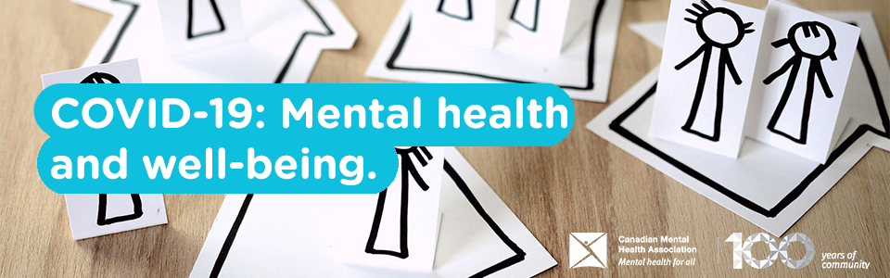

COVID-19 & Mental Health
A pandemic is a very stressful event for individuals and communities. It’s normal to feel some stress and anxiety. It’s also very common for people to display great resiliency during times of crisis.^{[1]}
We should remember that this is absolutely the time to lean on each other. Even if we can’t be close physically, we need to stay close emotionally. So, while you’re staying in, stay in touch with each other, and reach out if you need support.
CMHA has put together some resources and suggestions to help support your mental health at this time of uncertainty.
Relevant resources:
- 6 tips to respond to employee anxiety about COVID-19
- CMHA offers tips to support mental health amid concerns of COVID-19 pandemic
- Pandemic pushing your anxiety buttons?
- ‘Social distancing’ is a misnomer: we should be physically distancing, but remain as social as ever
- I’m feeling stressed due to the pandemic
Here are some credible sources of information that they recommend:
- Your local public health unit
- Your provincial/territorial public health authority
- The Government of Canada’s COVID-19 web page
- World Health Organization

